Program Information | [Lesson Title]  What Does Your Future Hold?  Write a Career Research Paper | TEACHER NAME  Laure Gaunt | PROGRAM NAME  Maplewood Career Center
Program Information | [Unit Title]  Career & Work | NRS EFL  5 – 6 | TIME FRAME  Up to 10 class sessions

Instruction | ABE/ASE Standards – English Language Arts and Literacy
Instruction | Reading (R) |  | Writing (W) |  | Speaking & Listening (S) |  | Language (L)
Instruction | Foundational Skills |  | Text Types and Purposes | W.5.2  W.6.1  W.6.2 | Comprehension and Collaboration |  | Conventions of Standard English | L.5.1  L.5.2
Instruction | Key Ideas and Details |  | Production and Distribution of Writing |  | Presentation of Knowledge and Ideas | S.5.2  S.6.4 | Knowledge of Language
Instruction | Craft and Structure |  | Research to Build and Present Knowledge | W.6.3  W.5.4  W.6.4 |  |  | Vocabulary Acquisition and Use | L.6.2
Instruction | Integration of Knowledge and Ideas |  |  |  |  |  | Benchmarks identified in RED are priority benchmarks. To view a complete list of priority benchmarks and related Ohio Aspire lesson plans, please see the Curriculum Alignments located on the Teacher Resource Center (TRC).

 | LEARNER OUTCOME(S)  - Students will choose a topic to research that relates to their career path and write a paper on that career. | ASSESSMENT TOOLS/METHODS  - Outline  - Career research paper  - Rubric  - Teacher observation
LEARNER PRIOR KNOWLEDGE

- Students starting this paper should possess higher skill levels in reading/writing and in most cases be familiar with the research paper process. Student skills should include prior writing experience with essays and English skills.
- This is an introduction to research paper writing and prepares students with an overview of what to expect in college. Students will decide on a career to research.
- A career awareness inventory could be completed prior to lesson if students are unsure of their own career path.

 | INSTRUCTIONAL ACTIVITIES  - Discuss with students what a research paper involves. A research paper is a report summarizing the answers to the research questions you generated from the sources you gathered information from. Then presenting them in a formal writing presentation. Use the Writing a Research Paper PowerPoint to talk about each of the steps involved in the writing process:  - Step 1. Choose a Topic  - Step 2. Find Information  - Step 3. State Your Thesis  - Step 4. Make a Tentative Outline  - Step 5. Organize Your Notes  - Step 6. Write Your First Draft  - Step 7. Revise Your Outline & Draft  - Step 8. Type Final Paper  Teacher Note Step 5 in the PPT contains information about plagiarism and the MLA format. If you would like more information on MLA style, please go to MLA Formatting and Style Guide.  When you turn in your final paper, it must contain the following items in this order:  Title Page  Final Outline  - Body of Paper  - Works Cited  - Additional Resource Page (optional)  - Introduce the Research Paper Rubric and criteria. Discuss what will be expected, explaining how the grading criteria are calculated.  - Students can read and discuss research papers similar to ones they are being asked to write; such as Pharmacist Essay or other selected papers.  - Students will write their research paper on their desired career pathway. Students can work in and out of class on this project; establish a timeline of the steps with completion dates.  - Students will work with peer(s) or teacher to revise draft of career research paper. Students will rewrite/revise research paper using constructive ideas presented by peers and teacher. Students will edit their papers for conventions.  - Class presentations can be made on their career choice and what area of study they would pursue in their academic career. | RESOURCES  Writing a Research Paper PowerPoint (attached)  MLA Formatting and Style Guide. (n.d.). Retrieved from http://owl.english.purdue.edu/owl/resource/747/01/  Notebook paper for student use  Student copies of Research Paper Rubric (attached)  Pharmacist Essay | Essay. (n.d.). Retrieved from http://www.bookrags.com/essay-2005/10/16/222823/34/  Compters for student use  Career Research Paper handout (attached)
DIFFERENTIATION

- Allow more time.
- Allow use of map as an alternative to an outline.
- Students with the same career interests could work together.
- Conduct mini lessons with students who are having similar difficulties.

Reflection | TEACHER REFLECTION/LESSON EVALUATION
Reflection | ADDITIONAL INFORMATION  Students can reflect on own personal thought on research outcomes. Did the outcome of the research paper satisfy the students? Are the job duties what the students expected? Is the amount of salary what the students expected.

Slide 1 |  | ___________________________________  ___________________________________  ___________________________________  ___________________________________  ___________________________________  ___________________________________  ___________________________________
Slide 2 | 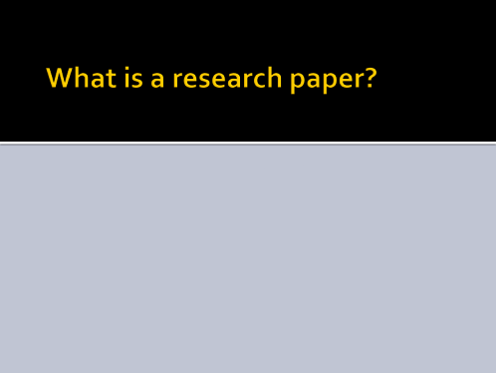 | ___________________________________  ___________________________________  ___________________________________  ___________________________________  ___________________________________  ___________________________________  ___________________________________
Slide 3 | 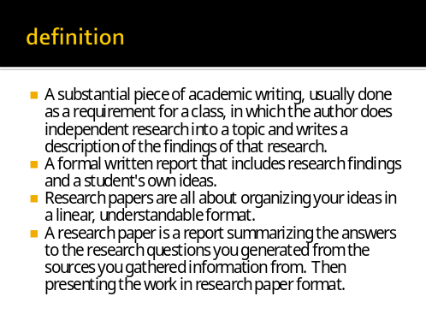 | ___________________________________  ___________________________________  ___________________________________  ___________________________________  ___________________________________  ___________________________________  ___________________________________
Slide 4 | 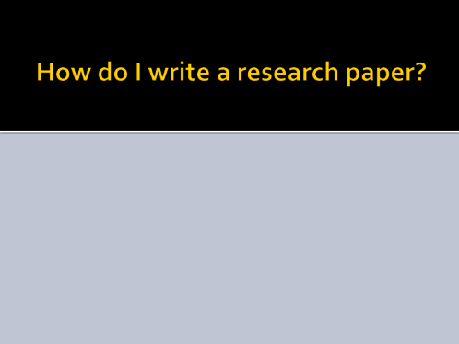 | ___________________________________  ___________________________________  ___________________________________  ___________________________________  ___________________________________  ___________________________________  ___________________________________
Slide 5 | 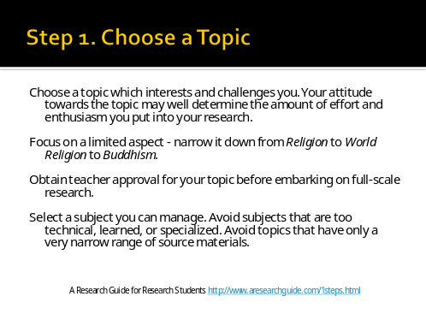 | ___________________________________  ___________________________________  ___________________________________  ___________________________________  ___________________________________  ___________________________________  ___________________________________
Slide 6 | 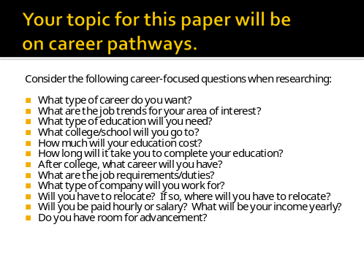 | ___________________________________  ___________________________________  ___________________________________  ___________________________________  ___________________________________  ___________________________________  ___________________________________
Slide 7 | 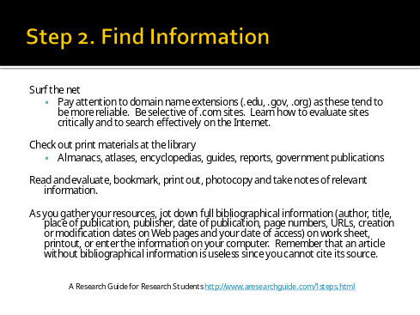 | ___________________________________  ___________________________________  ___________________________________  ___________________________________  ___________________________________  ___________________________________  ___________________________________
Slide 8 | 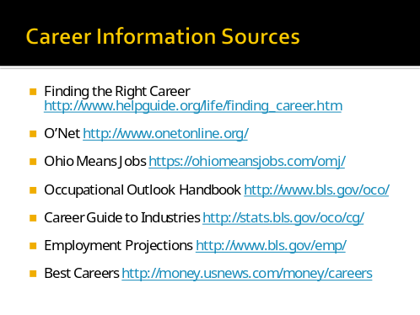 | ___________________________________  ___________________________________  ___________________________________  ___________________________________  ___________________________________  ___________________________________  ___________________________________
Slide 9 | 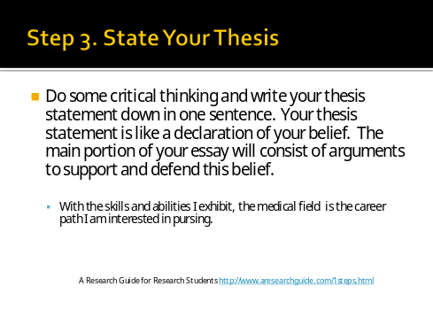 | ___________________________________  ___________________________________  ___________________________________  ___________________________________  ___________________________________  ___________________________________  ___________________________________
Slide 10 | 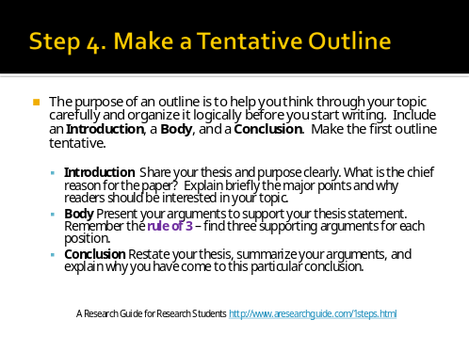 | ___________________________________  ___________________________________  ___________________________________  ___________________________________  ___________________________________  ___________________________________  ___________________________________
Slide 11 | 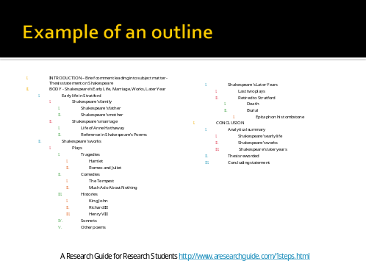 | ___________________________________  ___________________________________  ___________________________________  ___________________________________  ___________________________________  ___________________________________  ___________________________________
Slide 12 | 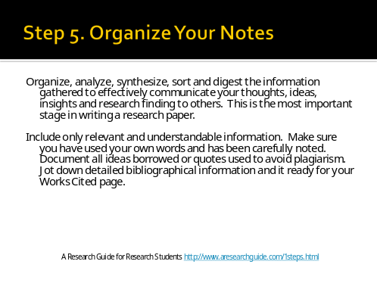 | ___________________________________  ___________________________________  ___________________________________  ___________________________________  ___________________________________  ___________________________________  ___________________________________
Slide 13 | 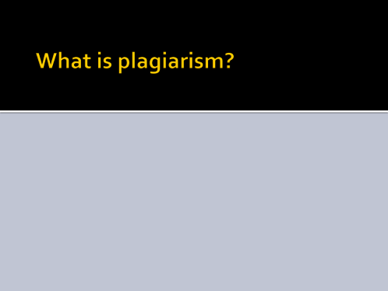 | ___________________________________  ___________________________________  ___________________________________  ___________________________________  ___________________________________  ___________________________________  ___________________________________
Slide 14 | 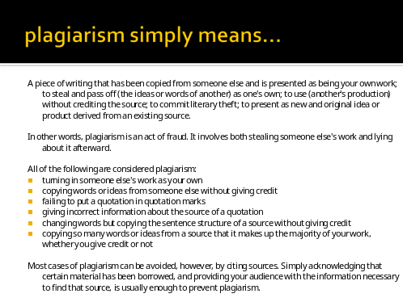 | ___________________________________  ___________________________________  ___________________________________  ___________________________________  ___________________________________  ___________________________________  ___________________________________
Slide 15 | 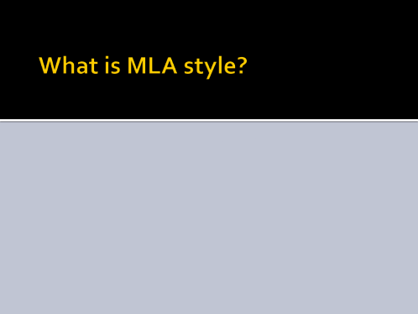 | ___________________________________  ___________________________________  ___________________________________  ___________________________________  ___________________________________  ___________________________________  ___________________________________
Slide 16 | 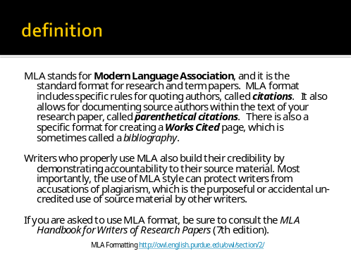 | ___________________________________  ___________________________________  ___________________________________  ___________________________________  ___________________________________  ___________________________________  ___________________________________
Slide 17 | 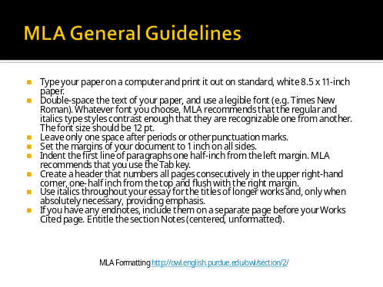 | ___________________________________  ___________________________________  ___________________________________  ___________________________________  ___________________________________  ___________________________________  ___________________________________
Slide 18 | 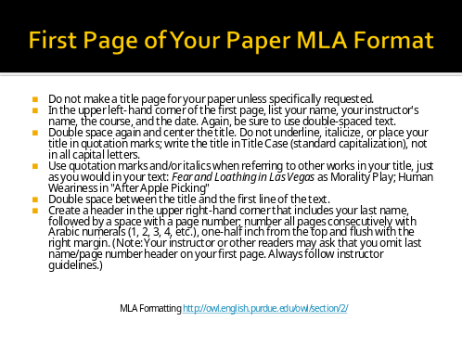 | ___________________________________  ___________________________________  ___________________________________  ___________________________________  ___________________________________  ___________________________________  ___________________________________
Slide 19 | 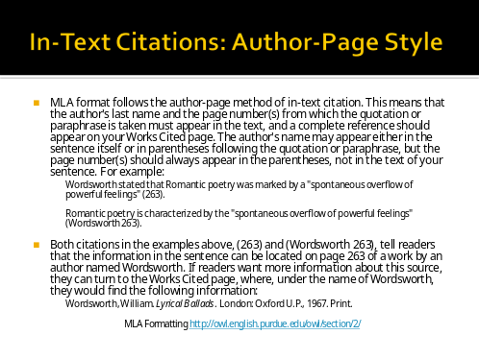 | ___________________________________  ___________________________________  ___________________________________  ___________________________________  ___________________________________  ___________________________________  ___________________________________
Slide 20 | 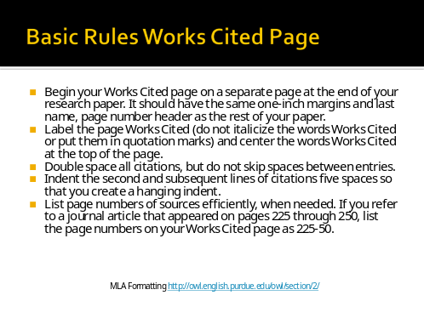 | ___________________________________  ___________________________________  ___________________________________  ___________________________________  ___________________________________  ___________________________________  ___________________________________
Slide 21 | 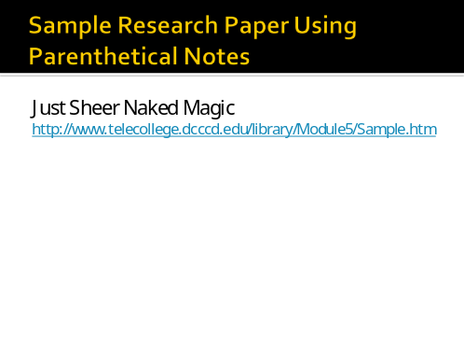 | ___________________________________  ___________________________________  ___________________________________  ___________________________________  ___________________________________  ___________________________________  ___________________________________
Slide 22 | 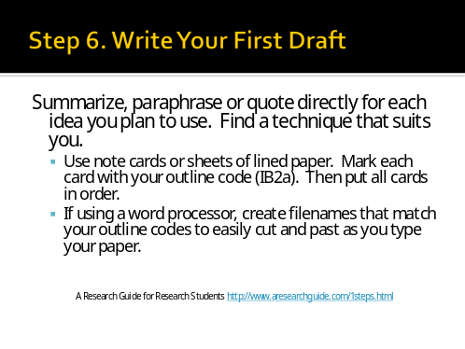 | ___________________________________  ___________________________________  ___________________________________  ___________________________________  ___________________________________  ___________________________________  ___________________________________
Slide 23 | 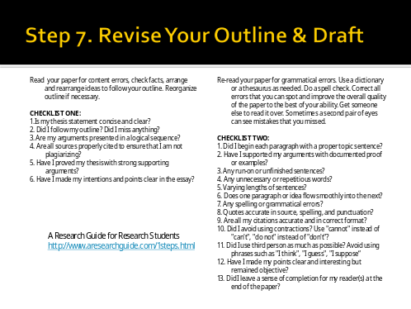 | ___________________________________  ___________________________________  ___________________________________  ___________________________________  ___________________________________  ___________________________________  ___________________________________
Slide 24 | 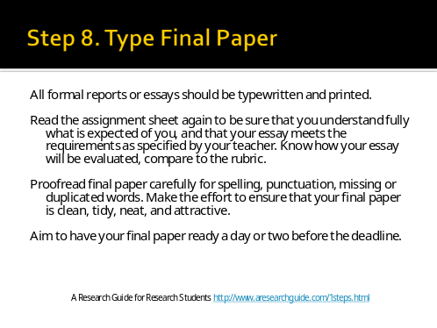 | ___________________________________  ___________________________________  ___________________________________  ___________________________________  ___________________________________  ___________________________________  ___________________________________

A Career as a Pharmacist

Summary: All about becoming a career as a pharmacist: the training and schooling requires is described as well as typical salaries.

Pharmacy

Pharmacists serve patients by providing information and advice on well-being. They also supply medication to patients in need of a better health. A qualified pharmacist must go through a certain amount and type of schooling to obtain certain degrees; these degrees will make an individual eligible to become a qualified pharmacist. Many colleges and universities across the United States offer great schooling to be part of this profession. There are many reasons for people to join such an appealing profession to with benefits such as a great living.

Pharmacists are experts in drugs developed to treat and prevent human diseases. They advise doctors and patients on which prescriptions and over-the-counter drugs, medicines and therapies are appropriate for treating certain health conditions. They also prepare medications, fill prescriptions, and teach patients how to take the medication. Therefore, they must have excellent communication skills so that they can listen, understand, and ask questions. In addition, they must be able to express ideas clearly when speaking and writing so that patients understand correctly. A pharmacist must make sure that they explain the composition of the drug, the side effects, the dosages, and the any complications with other drugs the patient might use. A person in this profession must be organized and always focused to make sure they do not give the wrong medication to the incorrect person because the consequences can be fatal. In summary for a person to be a successful pharmacist they must be a focused, well trained, and organized person.

To become a pharmacist a person must go to a school that offers a pharmacy program and receive a degree in pharmacy to prove to patients and employers that a person is qualified for this job. Students do not have to complete a formal pre-pharmacy program but they must have certain pre-requisites such as general biology, physics, and chemistry with labs. They must also be educated in areas such as math, humanities, communication, and writing skills. Once a student is enrolled in a pharmacy school they must complete at least two years of pre-pharmacy courses in college, graduate from a four-year pharmacy program, complete an internship; and pass a state licensing exam. These programs teach students to fill prescriptions, advise patients, and confer with physicians and other health workers. Once a student has gone through all of the schooling they will receive certain degrees. The degrees are Bachelor of Pharmacy, Graduate Diploma in Community Pharmacy, Postgraduate Diploma in Pharmacy, Master of Science (Pharmacy), Doctor of Philosophy. There are many colleges and universities across the United States that offer a pharmacy program. A few would be The University of Arizona, Rutgers University, Long Island University, and St. John's University. A student that follows all the correct steps and is focused and dedicated they will be prepared be a successful pharmacist. There are multiple reasons for a person to want to become a pharmacist such as the large salary which averages between 80,000 to 120,000 dollars a year.

Pharmacist Essay | Essay. (n.d.). Retrieved from http://www.bookrags.com/essay-2005/10/16/222823/34/

Career Research Paper

Name: Date:

- What type of career do you want?

- What are the job trends in your area of interest?

- What type of education will you need?

- What college/school will you go to?

- How much will your education cost?

- How long will it take you to complete your education?

- After college, what career will you have?

- What are the job requirements/duties?

- What type of company will you work for?

- Will you have to relocate? If so, where will you have to relocate?

- Will you be paid hourly or salary? What will be your income yearly?

- Do you have room for advancement? If so, then what are your options?

Research Paper Rubric Name ____________________________ Date ________________________ Score ______________

Category | Exceeds Standard (4) |  | Meets Standard (3) |  | Nearly Meets Standard (2) |  | Does Not Meet Standard (1) | No Evidence (0) | Score
Title Page | Title, Your Name, Teacher’s Name, Course Period, Date, Neatly finished/no errors |  | Evidence of four |  | Evidence of three |  | Evidence of two or less | Absent
Thesis Statement | Clearly and concisely states paper’s purpose in single sentence, which is engaging and thought provoking |  | Clearly states paper’s purpose in a single sentence. |  | States the paper’s purpose in single sentence. |  | Incomplete and/or unfocused. | Absent, no evidence
Intro | Intro is engaging, states main topic and previews the structure of the paper. |  | Intro states main topic/previews structure of paper. |  | Intro states main topic, but does not adequatel preview structure of paper. |  | No clear intro or main topic and structure of paper is missing. | Absent, no evidenc
Body | Each paragraph has thoughtful suporting detail sentences that develop main idea. |  | Each paragraph has sufficient supporting detail sentences that develop main idea. |  | Each paragraph lacks supporting detail sentences. |  | Each paragraph fils to develop main idea. | Absent, no evidence.
Organizational Structural | Writer demonstrates logical subtle sequencing of ideas through well-developed paragraphs, transitions are used to enhance organization. |  | Paragrap development present but not perfected. |  | Logical organization; organization of ideas not fully developed. |  | No evidence of structure or organization. | Not applicable.
Conclusion | Conclusion, is engaging/restates thesis. |  | Conclusion restates thesis. |  | Conclusion does not adequately restate thesis. |  | Incomplete/unfocused | Absent
Mechanics | No errors in punctuation, capitalization and spelling |  | Almost no errors in punctuation, capitalization and spelling |  | Many errors in punctuation, capitalization and spelling. |  | Numerous and distracting errors in punctuation, capitalization and spelling. | Not applicable
Usage | No errors in sentence structure and word usage. |  | Almost no errors in sentence structure and word usage. |  | Many errors in sentence structure and word usage. |  | Numerous and distracting errors in sentence structure and word usage. | Not applicable
Citation | All cited works, both text and visual, are done in the correct format with no errors. |  | Some cited words, both text and visual, correct format, inconsistencies evident. |  | Few cited works, but test and visual, correct format. |  | Absent | Not applicable
Bibliography | Done in correct format with no error. Includes 5 major references (e.g. minimum two career related materials along with Internet sites). |  | Done in correct format with few errors. Includes 5 major references (e.g. minimum two career related materials along with Internet sites). |  | Done in correct format with some errors. Includes 4 major references (e.g. two career related materials, no more than two Internet sites) |  | Done in correct format with many errors. Includes 3 major references (e.g.career related materials, books, but no more than two Internet sites) | Abent or only sits are iInternet sites
 |  |  |  |  |  |  |  | Total Score

